Instruction Manual For Guide Module (Ipad)

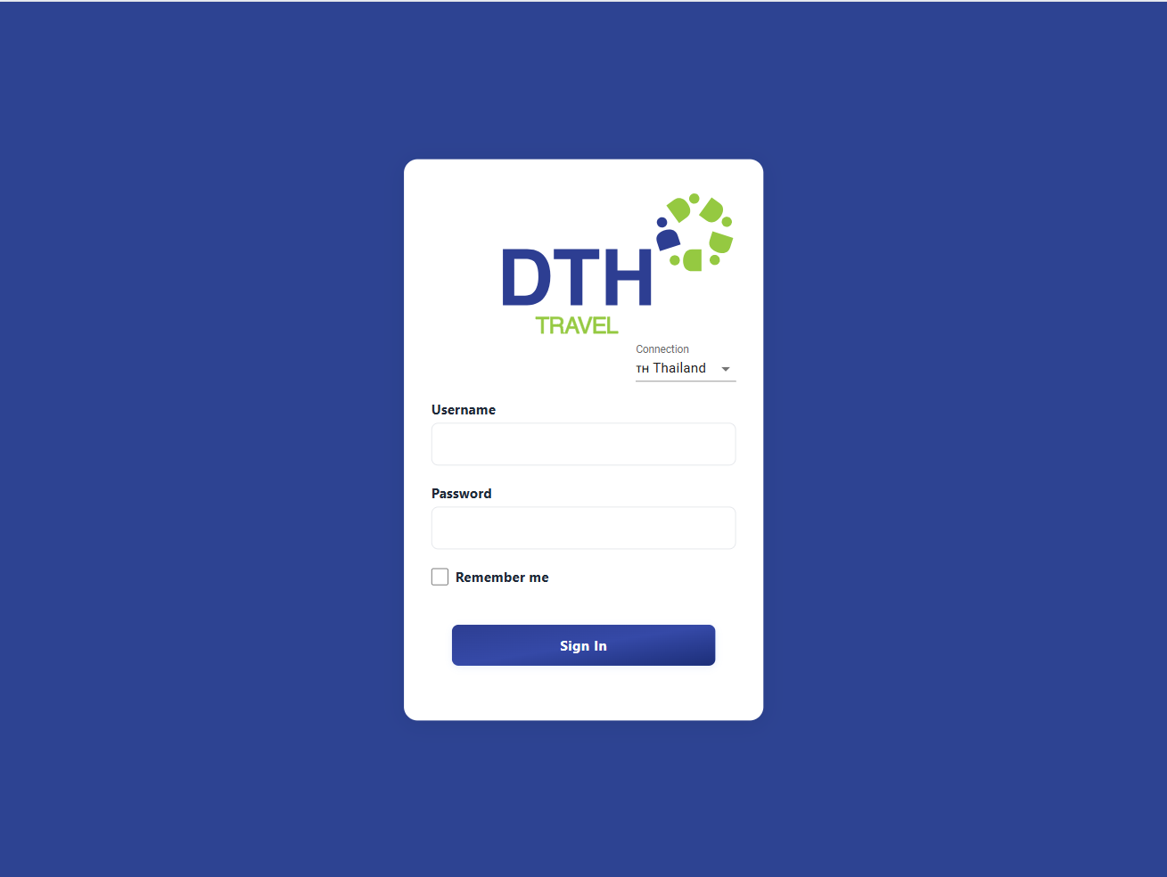

Login Button

Select Connection

Enter Username,Password

**1. Login Page**

On the **Login page**, users must:

1. Enter their **Username** and **Password**.
2. Select the appropriate **Connection** based on their **country**.
3. Click the **Login** button to access the system.

After successful login, the system will automatically redirect you to the **Jobs List** page.

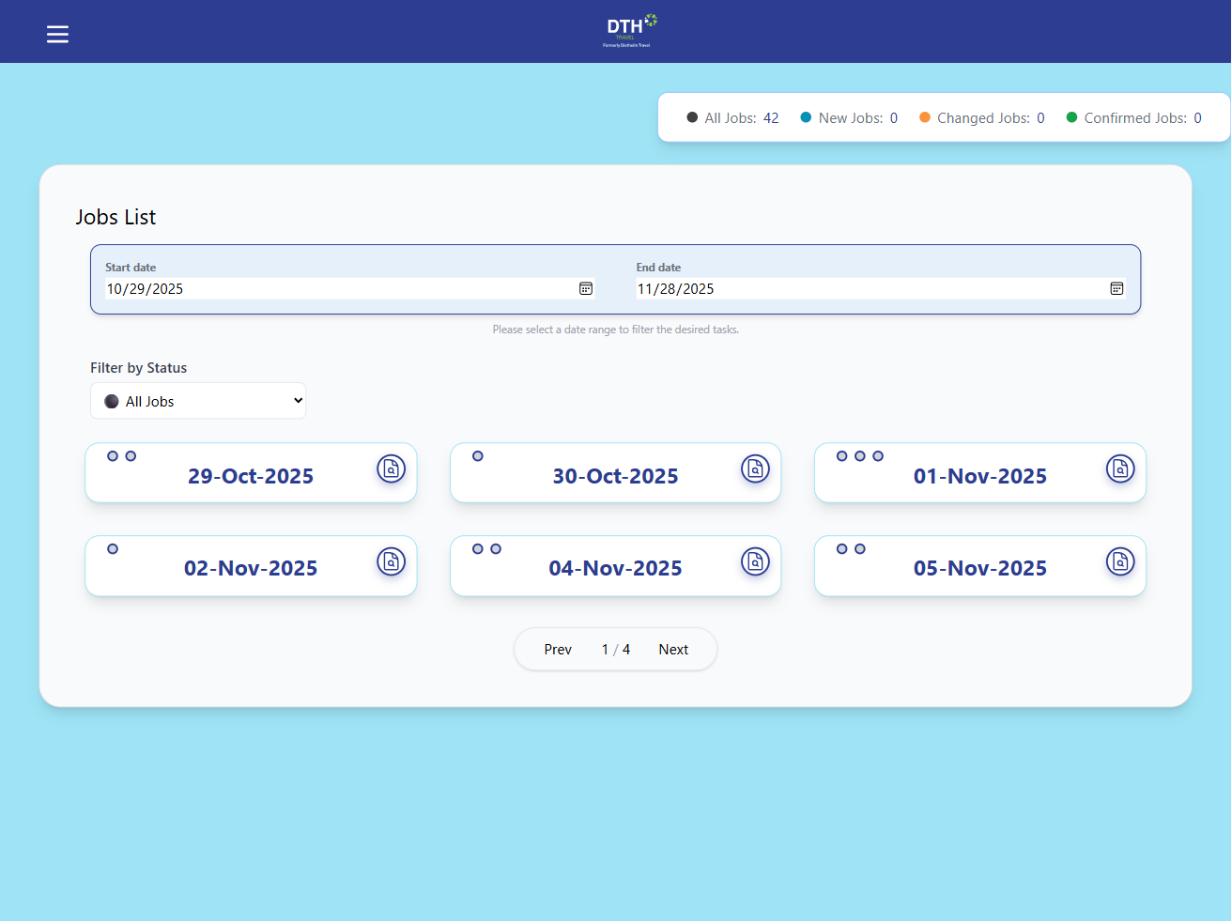

Select date to

Select date from

**2. Jobs List Page**

The **Jobs List** page displays jobs based on the selected date and time.  
Users can freely **choose the desired date** to view available jobs.

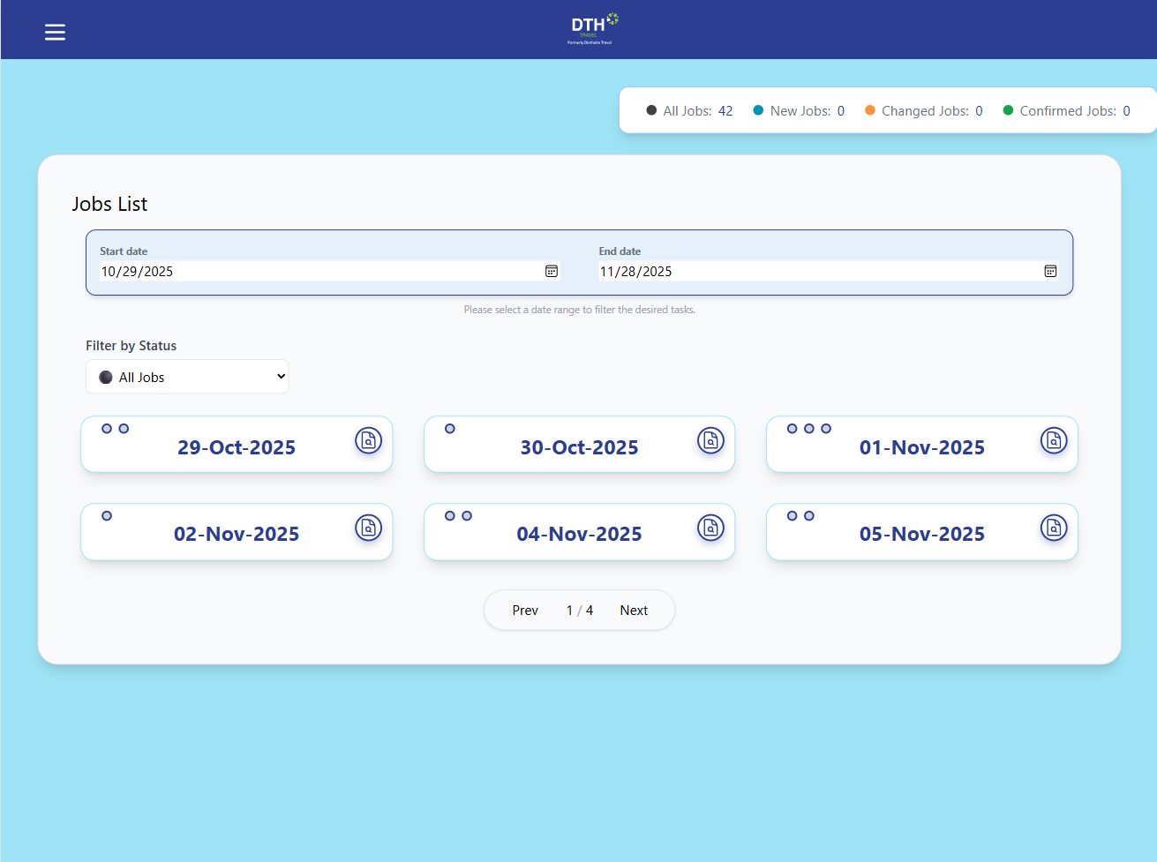

Filter jobs option

Current job status

**3. Filtering by Status**

Users can **filter jobs** by their status using the **Filter** option.  
The current job status is displayed in the **top-right corner** of each job card.

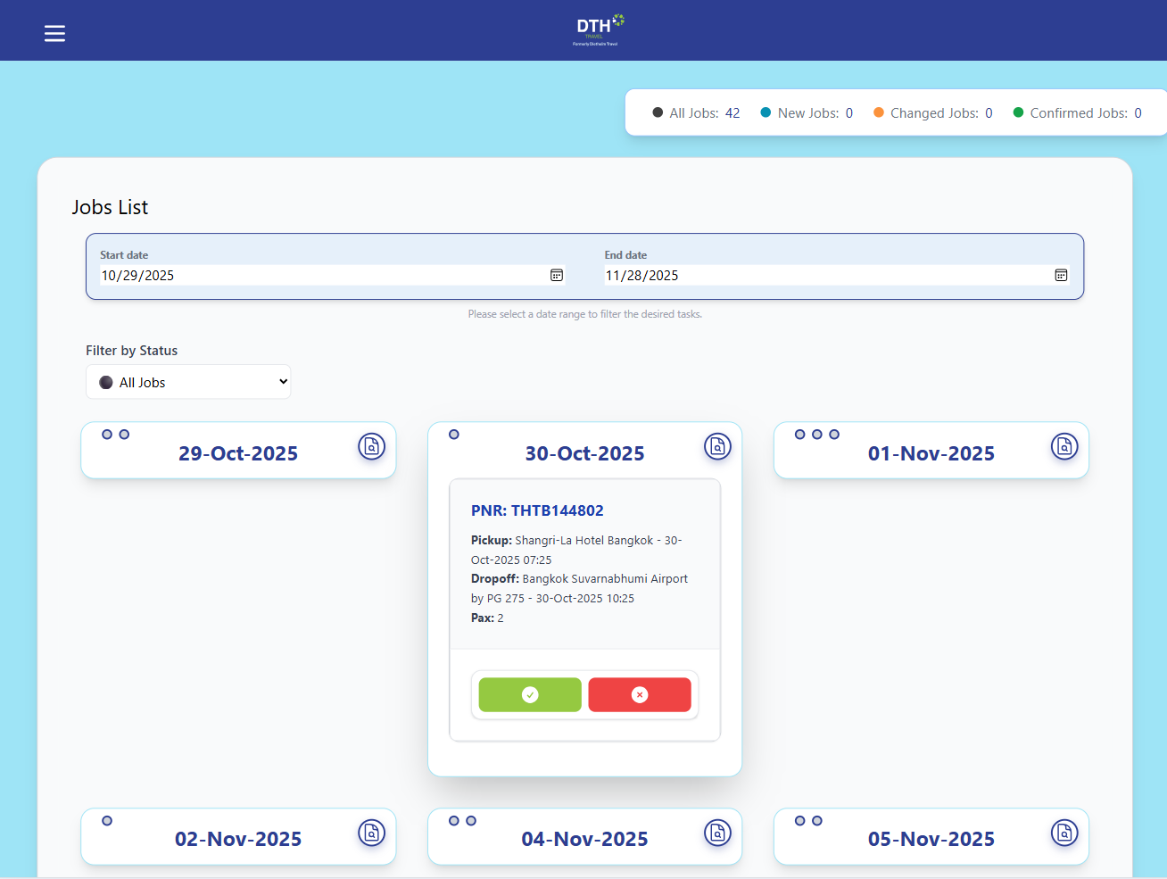

Reject the job

Accept the job

Clicking on a job block to expand detailed information

**4. Viewing Job Details**

By **clicking on a job block** for a specific date, users can view **detailed information** about that job.  
From this view, users can choose to **accept** or **reject** the job.

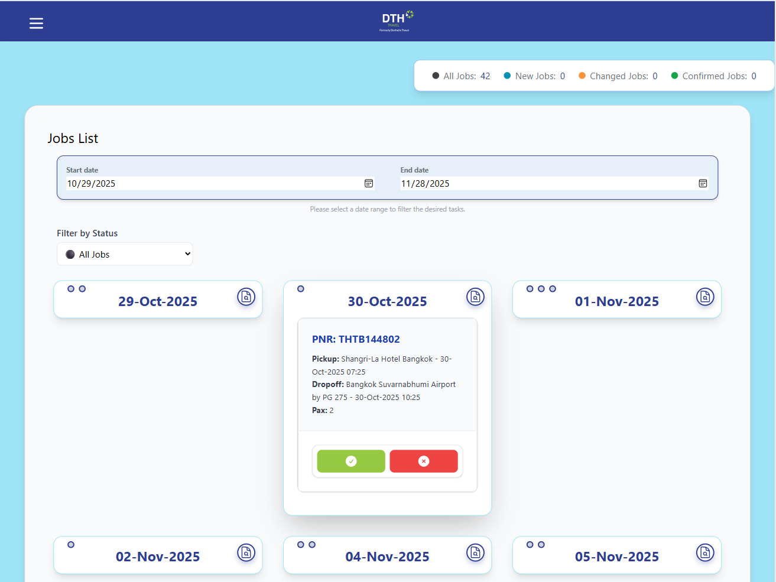

A document icon

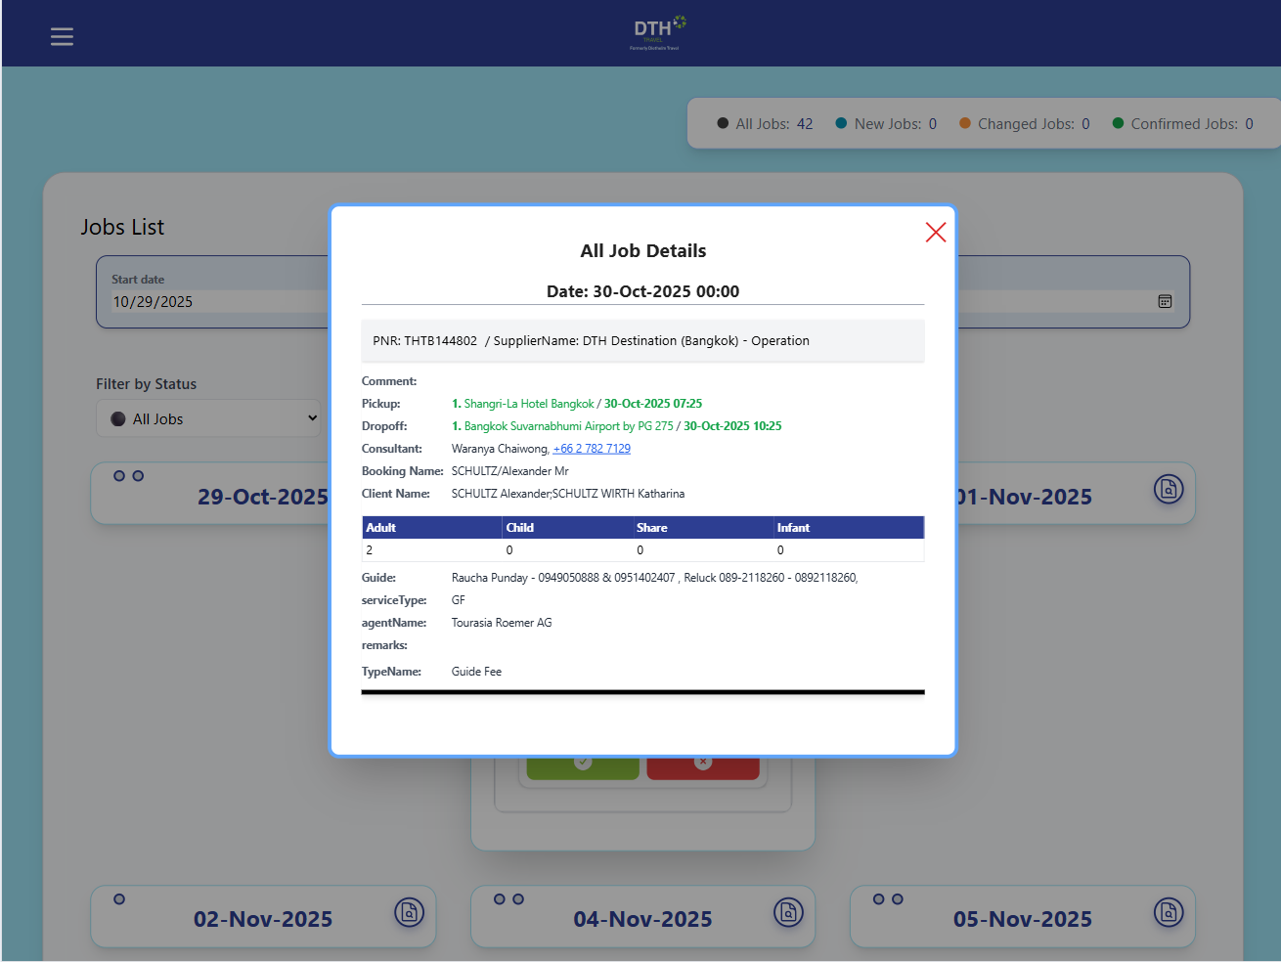

**5. Viewing Full Job Details**

A **document icon** is available on the job card.  
Clicking this icon will display **all job details**.

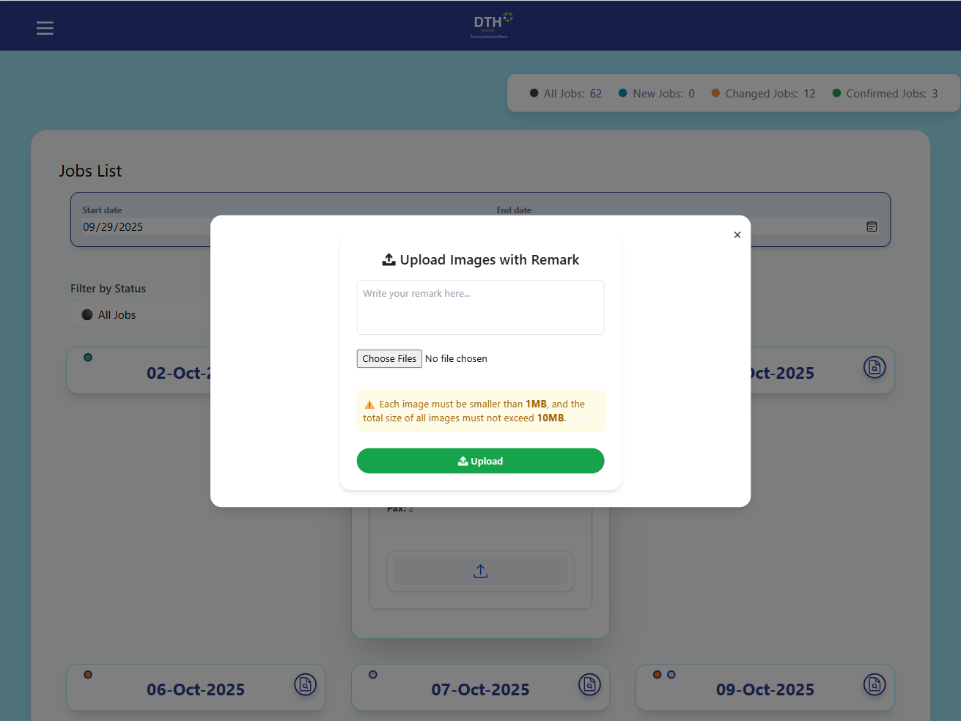

**6. Uploading Remarks and Images**

After **accepting a job**, users can **upload remarks and images** related to that job.

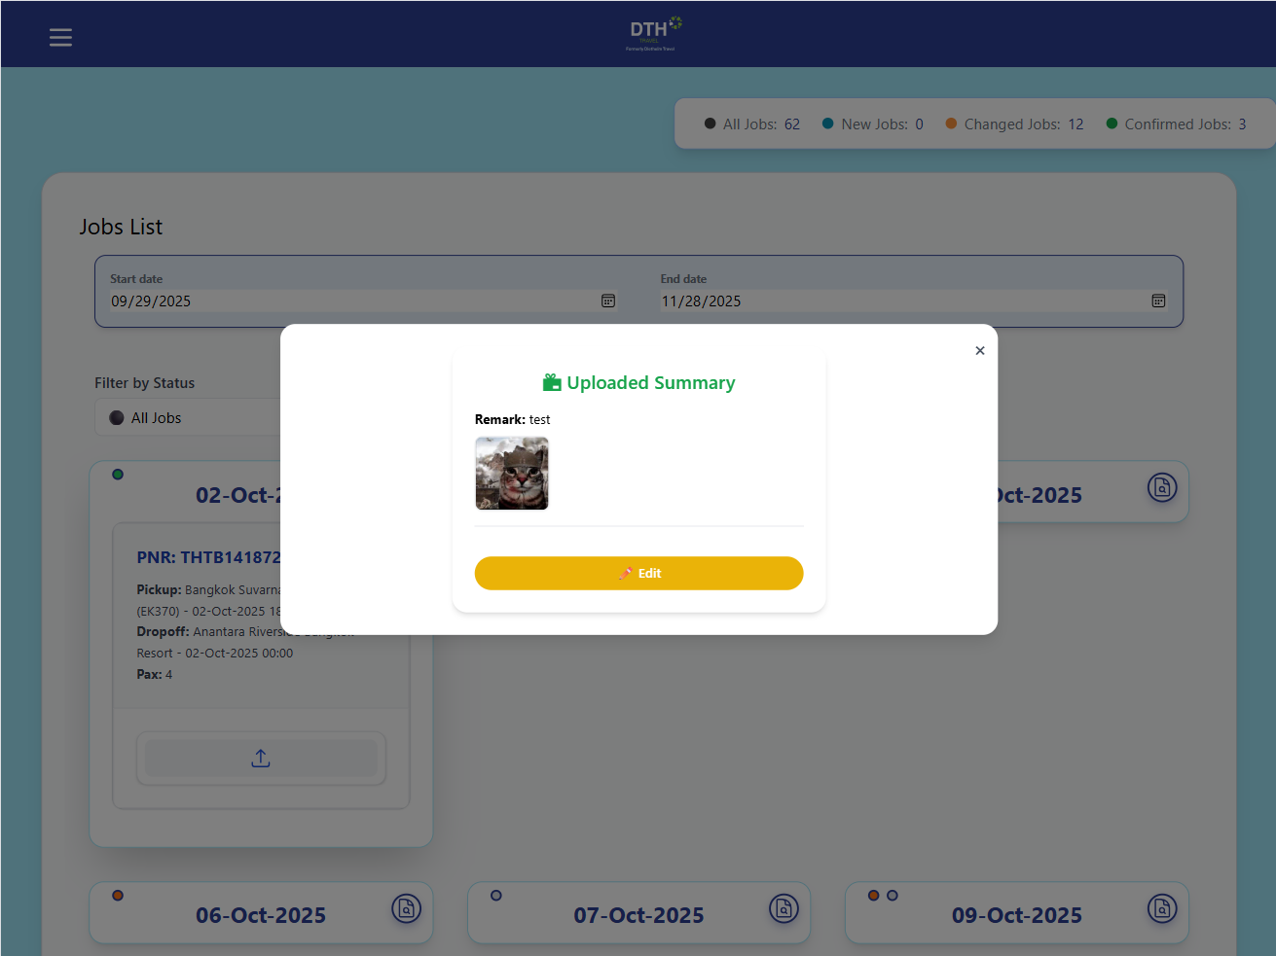

**7. Editing Remarks and Images**

Users can **edit uploaded remarks and images later** if any updates or corrections are needed.

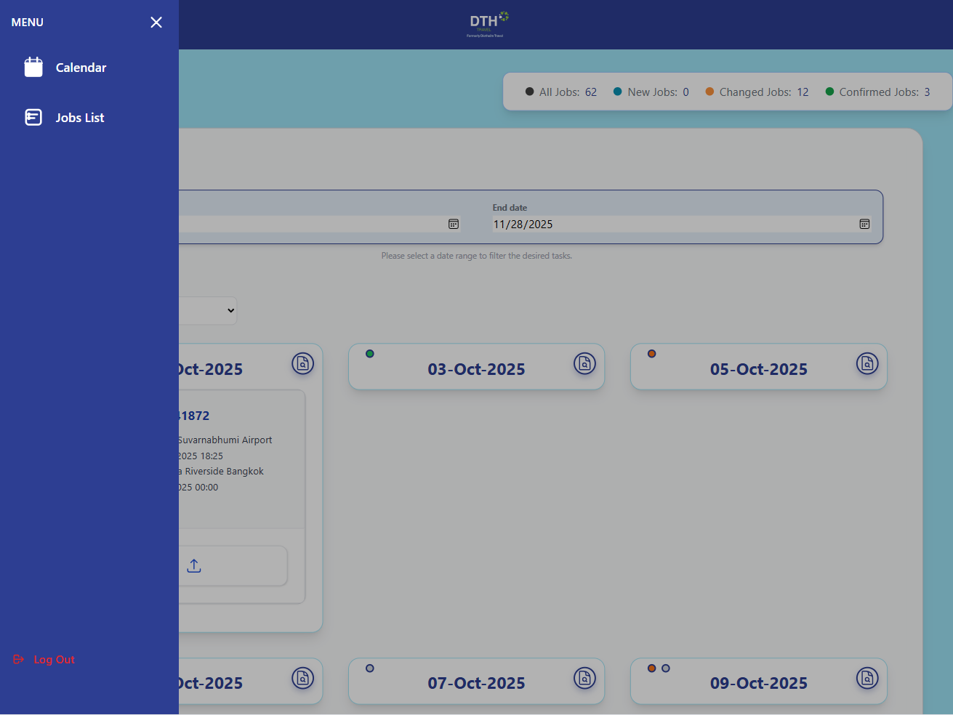

Calendar menu

**8. Viewing Accepted Jobs in Calendar**

Once a job is accepted, users can view their scheduled jobs via the **Calendar menu** on the **left-hand side** of the interface.

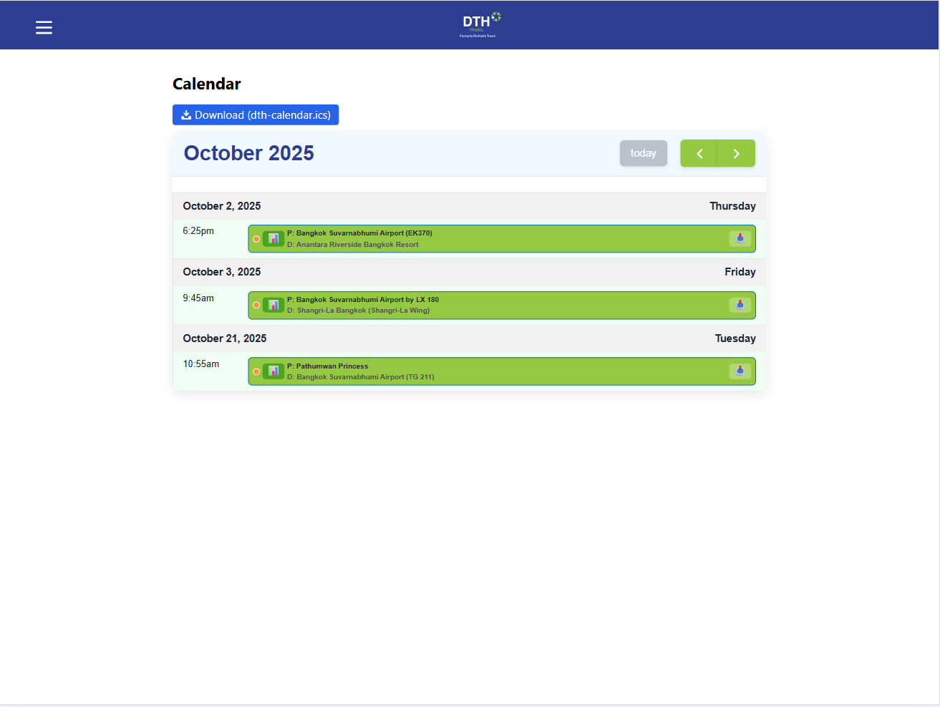

To export selected dates to their personal calendar

To export selected dates to their personal calendar

**9. Exporting Schedule to Calendar**

Inside the **Calendar menu**, users can **export selected dates** to their **personal calendar** by clicking the **Export button**.

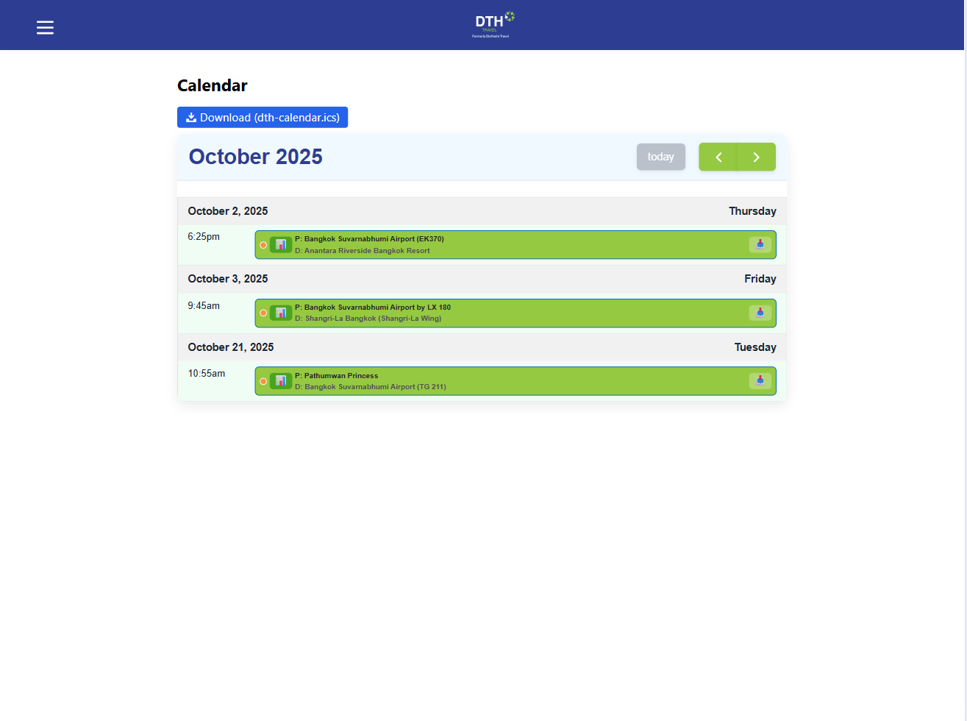

Go to dashboard

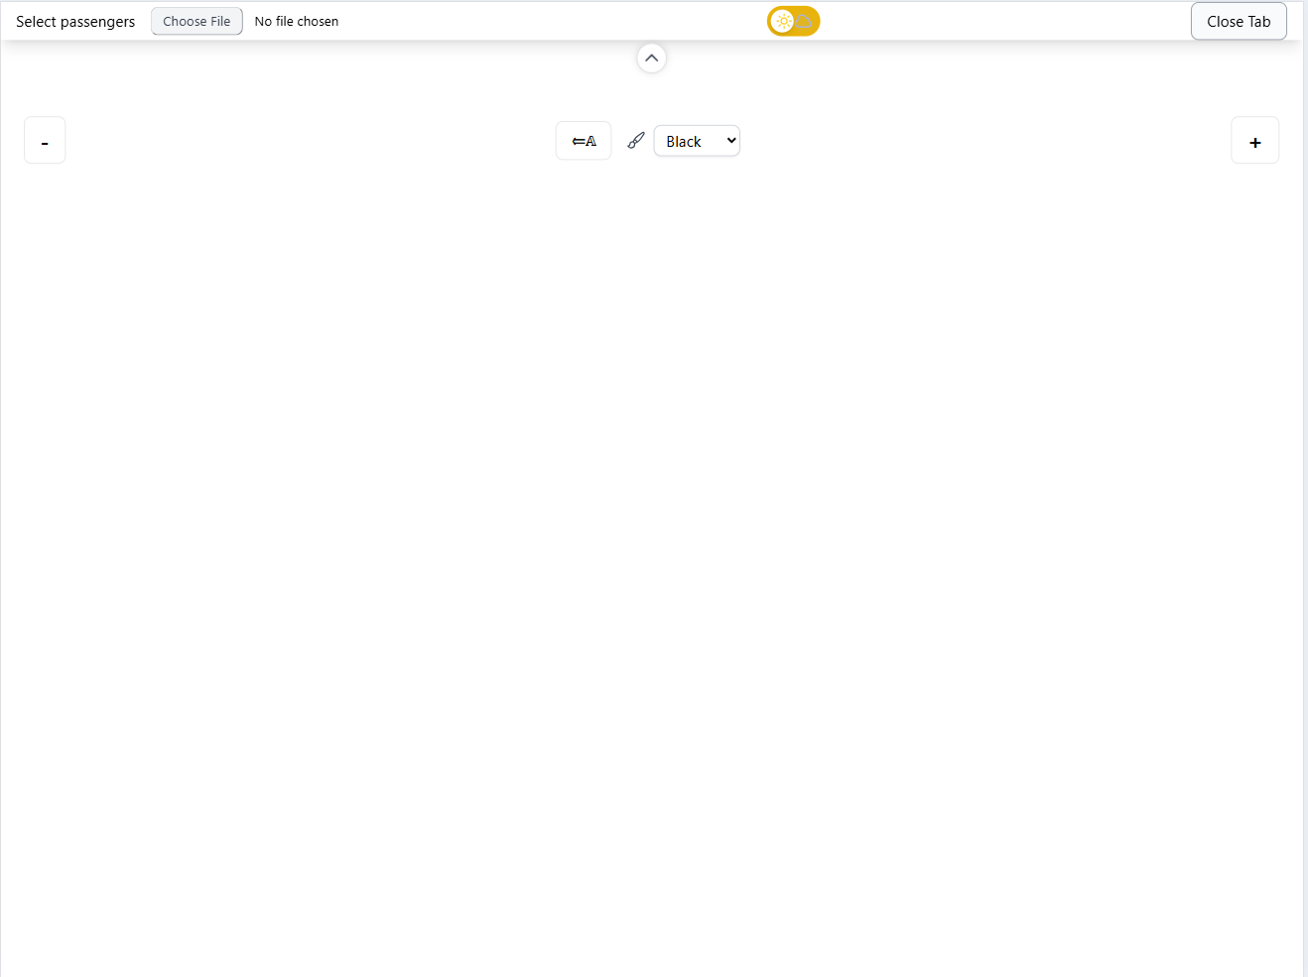

Select image

Select pnr

Increase or reduce font size

Text Moving

Change text colors

**10. Dashboard**

**The Customer Guide Display is designed for passengers or customers to easily see who is picking them up.**

**Key Features:**

* **Read-only display for customers.**
* **Shows Guide’s Name, Company, or Vehicle Info clearly.**
* **Use large font sizes and high-contrast colors for easy visibility.**
* **Optionally display logos, badges, or instructions for clarity.**
* **Updated in real-time by staff through the Jobs List or Admin Panel.**